**Configuring Github**

Follow the below steps to setup the Versioning control in your Eclipse Juno

1. **Install the EGit plugin**
   1. Navigate to Help – Eclipse Marketplace
   2. Search for EGit

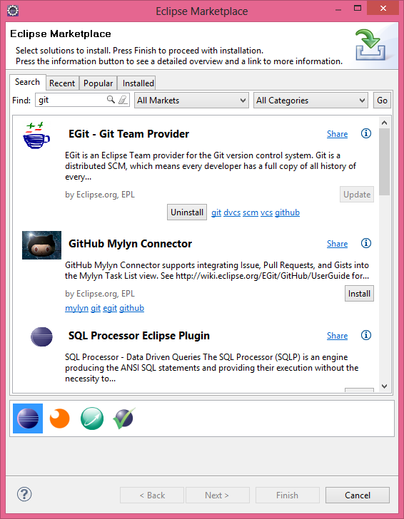

1. **Open a new perspective**
   1. Click on open perspective at the top tool bar
   2. Select Git Repository Exploring

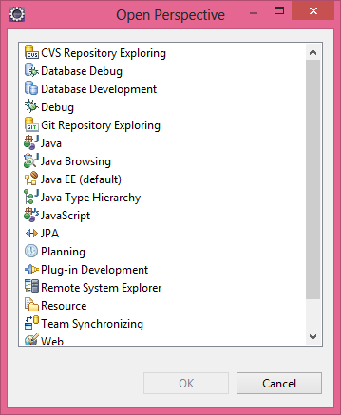

1. **Clone a Git repository and add the clone to the view**
   1. Enter the following URI : https://github.com/knk1988/UniversitySouvenirApplication.git and click on next
   2. Repository will be created

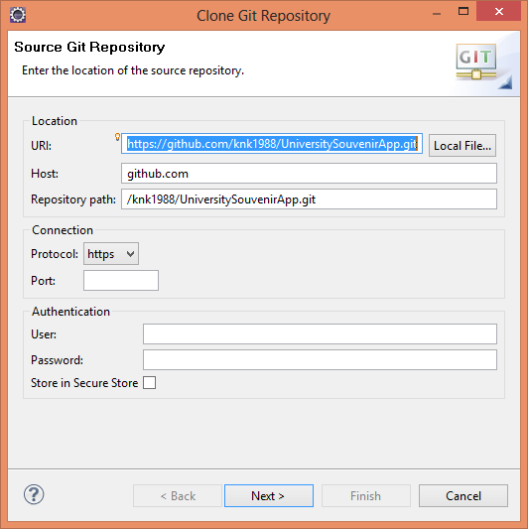

1. **Eclipse Preferences**
   1. The Eclipse Git functionality allows you to configure your default user and email address for a commit. Select Window →Preferences → Team → Git → Configuration to set them up.
   2. You can add entries to your Git configuration by pressing the Add Entries button on the Git Configuration preference page. To add your user, use the user.name as key and your real name as value. Repeat the procedure for your email address.

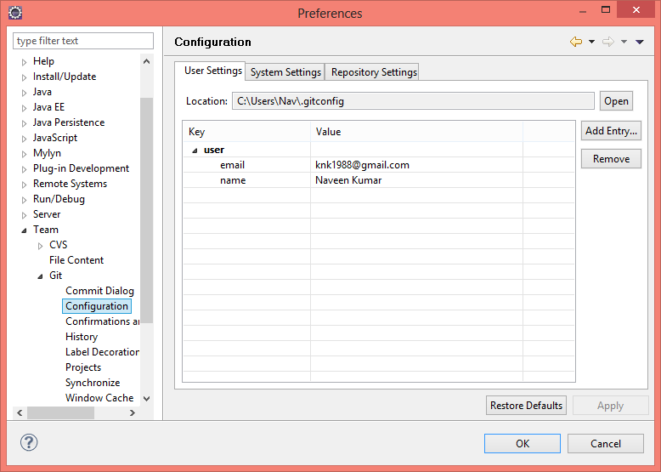

1. **Making Changes and Checking in using Git Staging**
   1. Eclipse gives you several options to stage and commit your files. The *Git Staging* *view* is an convenient way for this.
   2. Open the *Git Staging* *view* via the *Window* → *Show View* → *Other...* → *Git* → *Git Staging* menu.
   3. In this *view* select all files which have changed and drag them into the *Staged Changes* area. Write a descriptive commit message and press the *Commit* button which is hightlighted in the following screenshot.

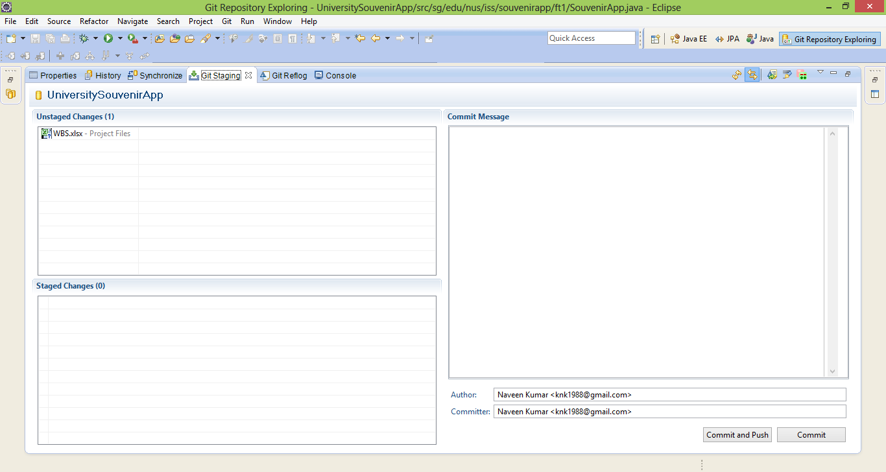

1. **View the commit history**
   1. To see the history of a resource, select your project, a file or a folder, right-click on it and select the *Show in*→ *History*context menu entry. Alternative you can use the Alt+Shift+W shortcut and select the *History*entry.

